**Synthesis of Highly Active Crystalline Carbon Nitride Prepared in Various Salt Melts for Photocatalytic Degradation of Phenol**

**Mohd Hayrie Mohd Hattaa*, Hendrik O. Lintangb-d, Siew Ling Leea,b & Leny Yuliatib-d**

1Department of Chemistry, Faculty of Science, Universiti Teknologi Malaysia,

81310 UTM Johor Bahru, Johor, Malaysia

2Centre for Sustainable Nanomaterials, Ibnu Sina Institute for Scientific and Industrial Research,

Universiti Teknologi Malaysia, 81310 UTM Johor Bahru, Johor, Malaysia

3Ma Chung Research Centre for Photosynthetic Pigments, Universitas Ma Chung, Villa Puncak Tidar N-01, Malang, 65151, East Java, Indonesia

4Department of Chemistry, Faculty of Science and Technology, Universitas Ma Chung, Villa Puncak Tidar N-01, Malang, 65151, East Java, Indonesia Email: leny.yuliati@machung.ac.id

*Corresponding author: mhayrie2@live.utm.my

**Abstract**

Crystallinity could have a decisive influence in photocatalytic performance. In this study, crystalline carbon nitride (CN) was successfully synthesized via an ionic melt polycondensation method using urea as the precursor in the presence of various salt melts, which were KCl-LiCl, KCl-ZnCl2 and KCl-NaCl. It was confirmed that all salt melts could result in the formation of CN, as supported by Fourier transform infrared (FTIR) and diffuse reflectance ultraviolet-visible (DR UV-Vis) spectroscopies. However, only KCl-LiCl could form crystalline CN as evidenced by its X-ray diffraction (XRD) pattern where in addition to diffraction peaks at 13.5 and 27.2°, new peaks were observed at 20.8, 29.2 and 31.5°. Specific surface area of CN prepared without salt melt was around 55 m2/g. The specific surface area was maintained when using KCl-LiCl (51 m2/g), but it was decreased in the presence of KCl-ZnCl2 (20 m2/g) or KCl-NaCl (11 m2/g). Photocatalytic activity of the CN samples was then evaluated for phenol degradation under solar simulator for 6 hours, which was analysed by a high performance liquid chromatography (HPLC) using a Hypersil GoldTM PFP column. The CN prepared without the salt melt only showed activity of 10%, while the use of KCl-LiCl significantly improved the activity to 25%. On the other hand, the CN prepared in the presence of KCl-ZnCl2 and KCl-NaCl gave phenol degradation of 7 and 14%, respectively. This work demonstrated that the crystallinity and the maintained large specific surface area of the CN were both crucial to achieve the high activity.

**Keywords:** Carbon nitride, crystallinity, KCl-LiCl, phenol, salt melts.

**Introduction**

Graphitic carbon nitrides, CN or C3N4 are a class of a polymeric material that consists of carbon (C) and nitrogen (N) elements [1] that are found to have many applications in catalysis field such as electrocatalysis, oxidation catalysis, catalyst support and nanocomposite fillers [2]. Recently, CN has attracted a significance attention in photocatalysis field owing to its stability in the photocatalytic water-splitting reaction under visible light irradiation [3]. However, most of the synthesized CN that has been reported in literature widely was found to be in amorphous phase [4-6]. For most applications in photocatalysis field, the directional flow of electrons are depends on the organization of the molecules in the structure in relation to their crystallinity [7]. In the other words, the photocatalytic properties are sensitively affected by the crystallinity of the photocatalyst [8]. However, constructing a crystalline photocatalyst that reduced electron-hole combination and works excellently in visible light region is promising but can be a challenging task. Typically, a crystalline CN material that have a well-defined morphologies and better surface area can be synthesized using LiX/LX salt melts (X=Cl, Br) as reaction media [9,10]. The uses of salt melts as a medium for chemical process can be tracked back in the 1960s when Sundermeyer et al., showed that known organic chemistry reaction can be performed in molten salts [11,12]. Chemical compounds such as carbonyl and fluorocarbonyl pseudohalogenides

and cyanides, cyanates and thiocyanates of both silicon and carbon were among the chemical that successfully synthesized [13]. This successful chemical preparation proves that the good solvating properties of salt melts with respect to nitrides, carbides, cyanides, cyanates and thiocyanates. It can be suggested that the salt melts are a good solvent due to its high-temperature stability and its melting point below the polycondensation point of s-heptazine. In addition, the good solvation of the small molecular precursors and subsequent aggregates of higher molecular weight facilitated the condensation of the CN network [14].

**Materials and methods**

## Chemicals and Materials

Sodium chloride (100.0%) and potassium chloride (95%) were purchased from Fischer chemical while lithium chloride (99.0%) was purchased from Sigma-Aldric. Urea (99.5%) was purchased from QRëC while phenol was purchased from Scharlau Chemie (99.5%). All the chemical used in the synthesis procedure were used without purification.

## Synthesis Procedure

A 30 g of urea as CN precursor was calcined at 350 °C for 6 hours to prepare ~10 g of a mixture of intermediate contains melamine, cyanuric acid and ammelide. 5 g of the intermediate mixture was dissolve in 100 ml of ethanol and the solution was stirred and heated at 100 °C for 1-2 hours. Then, the intermediate was ground together with salt melts as shown in table 1. The composition of salt melts are 40.8% mol for KCl and 59.2 mol% for XCl (X = LiCl, NaCl and ZnCl2) as followed by reported journal. The mixtures (~5-10 g) were transferred into crucible and covered with lids. The crucibles were then placed in furnace and calcined at 550 °C for 4 hours with heating rate of 2.2 °C/min. The final products were removed from crucibles and washed with boiling water before isolated via filtration process followed by drying in the oven for overnight at 60 °C. The reference CN was prepared via direct polymerization of urea by heating 30 g of urea at 550 °C for 4 hours with heating rate of 2.2 °C/min.

**Table 1** Composition of salt melt in synthesis parameters

|  |  |  |
| --- | --- | --- |
| **Salt Mixture A/B** | **A content (g)** | **B content (g)** |
| KCl-NaCl | 3.04 | 3.45 |
| KCl-ZnCl2 | 3.57 | 8.04 |
| KCl-LiCl | 2.74 | 2.26 |

## Photocatalytic Degradation of Phenol

The photocatalytic performance of prepared samples/photocatalyst were evaluated by measuring the degradation of phenol. A 50 mg of photocatalyst were dispersed in 100 ml beaker containing 50 ml of phenol (50 ppm). Prior to the photocatalytic reaction, the solution was stirred in the dark environment for 30 minutes to reach the equilibrium. The reaction was carried out over 6 hours under solar irradiation. The remaining concentration of the solution was determined by using HPLC.

**Characterization**

The structural properties and crystallinity of the prepared samples were determined via X-ray diffraction, XRD using Bruker AXS Diffrac plus release 2000 diffractometer with CuK radiation (λ=0.15148 nm) and step size of 0.05° 2**. Nicolet-is50 FTIR spectrometer was used to determine the chemical bond and functional group in the samples. KBr pellet technique was used in the characterization; Meanwhile, A Shimadzu UV-2600 Diffuse Reflectance (DR) UV-visible spectroscopy is used to determine the absorption spectra of the sample with barium sulphate (BaSO4) as reference. The Nitrogen adsorption-desorption isotherm measurements were performed using Quantachrome NOVA Touch 4LX at 77K. Prior to the measurement, all the samples were degassed at 150 °C for 3 hours. The specific surface area (SSA) were measured using Brunauer-Emmett-Teller (BET) model for adsorption range of 0.01 <*p/po* < 0.3 using the Quantachrome TouchWin 1.0. software.

**Results and discussion**

## Structural Analysis

Figure 1 show that the materials prepared in KCl-NaCl (c) and KCl-ZnCl2 (d) and the reference CN (a) are in amorphous form as they only show broad peaks at 2** of 11° and 26°. The peak at ~26° which indexed as (002) plane is corresponded to interplanar stacking of conjugated aromatic rings. Meanwhile, another pronounced peak observed at ~12° is related to in-plane structural packing [4,5]. It was demonstrated that CN prepared in KCl-ZnCl has better structural order compared to CN as the diffraction pattern showed a slightly sharp peak at 26°. On the other hand, the final product prepared in KCl-LiCl confirmed to have crystalline phase and have a structure of poly(triazine imide)-like [15] and composed with crystalline phase. The crystalline peaks can be observed at 2** of 21, 26, 29 and 31° and it is in agreement with the one that has been reported [14]. It can be suggested that CN with high crystalline phase can be prepared via KCl-LiCl salt melts and varying the amount of salt melts in the reaction is expected to increase the crystallinity of the material. The preparation of CN in salt melts of KCl-NaCl was unable to improve the crystallinity as it was turned out that the melting point of KCl-NaCl was higher than the condensation of CN, therefore it could not act as a reactive solvent during synthesis [16]. A report by Fettkenhauer *et al* [17] demonstrated that CN prepared in ZnCl2 successfully formed a CN with high crystalline phase but preparing in salt melts KCl-ZnCl2 leads to formation of amorphous phase.

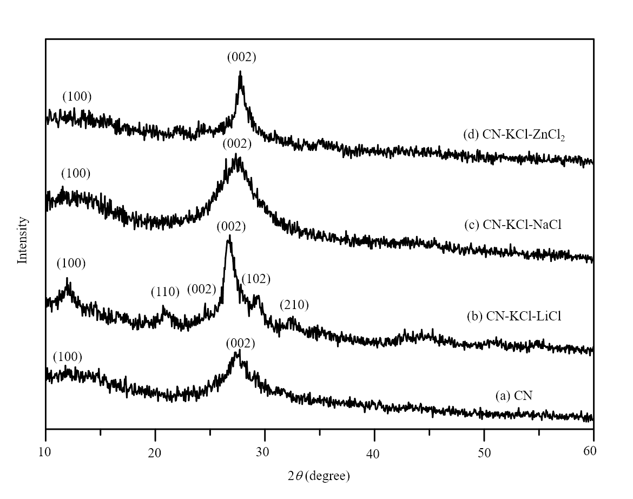

Figure 1: XRD patterns of (a) CN, (b) CN-KCl-LiCl, (b) CN-KCl-NaCl, (c) CN-KCl-ZnCl2.

## Optical Properties

Optical absorption properties of the prepared materials were investigated and carried out. As it can be seen in Figure 2, three absorption peaks were observed mainly at 277, 340 and ~375 nm. The peak at 277 nm was attributed to C=N indicating a π→π* charge transfer while the peak at ~375 was corresponded to the formation of C-N. On the other hand, the peak at 340 nm was corresponded to the formation of C=O of π→π* and n→π* electronic transition [18]. CN prepared in KCl-ZnCl2 has better absorption in visible light region compared to others. The pattern of absorption spectra of KCl-NaCl and KCl-ZnCl2 were typical for dyade materials such as carbon@TiO2, the absorption spectrum likely points out at charge transfer between CN and Zn containing species [19]. Reference CN showed a visible light absorption up to *ca.* 430 nm while CN-KCl-LiCl showed additional absorption up to 460 nm. Compared to reference CN, the absorption edge of CN-KCl-LiCl was significantly shifted by 40 nm towards the low energy region from 420 to 460 nm. The red shift was due to the low band gap energy resulted from the increase of particle size and crystallinity of the sample [20].

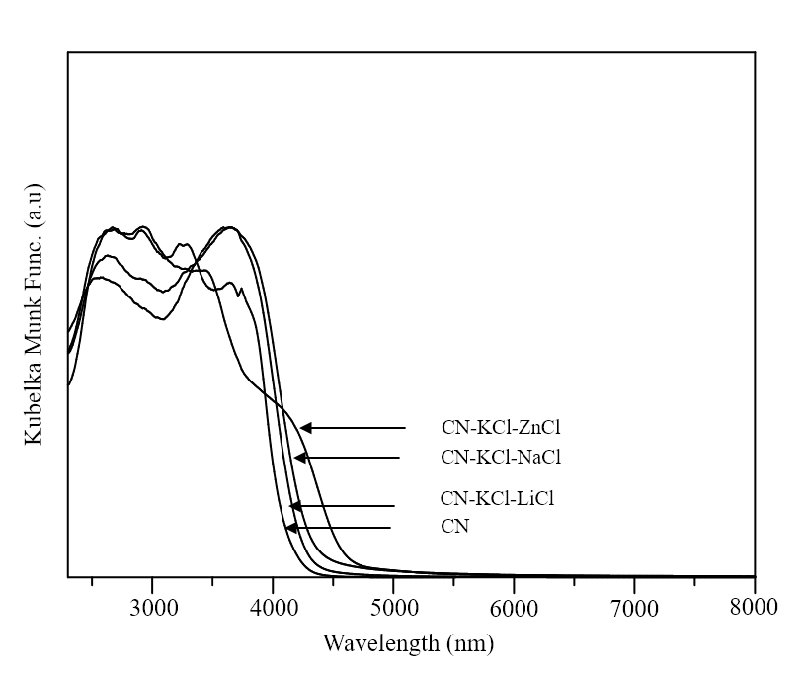

Figure 2: DRUV-Vis spectra of CN, CN-KCl-LiCl, CN-KCl-NaCl, CN-KCl-ZnCl2.

## Functional Groups

The formation of CN in all prepared samples can be proven by FTIR spectroscopy as shown in Figure 3. The successful formation of CN network structure can be shown from the vibration bands at 800 and 1200-1600 cm-1 [14], which corresponds to the characteristic breathing mode of triazine units and typical stretching modes of CN heterocycles. The bands at 1250, 1330, 1420 and 1460 cm-1 were attributed to the stretching mode of CN heterocycles while the band at 1636 cm-1 was attributed to stretching mode of C=N [14]. The presence of the absorption band at ~1350 cm-1 in CN-KCl-LiCl and CN-KCl-ZnCl2 suggests that both CN are built of triazine rather than of tri-*s*-triazine rings [21]. The broad band observed between 2400 and 3400 cm-1 indicates the stretching vibrations of surface hydroxyl groups (OH) and terminal and residual amino groups (NH2 and NH). In addition, it was observed that addition of salt melts during synthesis reaction causes broadening and subsequent overlap of the absorption band while unmodified CN shows more defined vibration peaks. It can be noted that the small peak appeared at 2179 cm-1 except for CN was attributed to the formation of N=C=N or C≡N. For CN-KCl-LiCl, it was suggested that the intercalation of lithium and chlorides ions [14] in the stacking layer of CN might break the continuity of the CN networks structure, thus resulting in the formation of a less condensed framework in the structure [5]. For samples CN-KCl-NaCl and CN-KCl-ZnCl2, although the reason is unclear, it was suggested that the salts could act as a template thus the final product formed was having mesoporous structure.

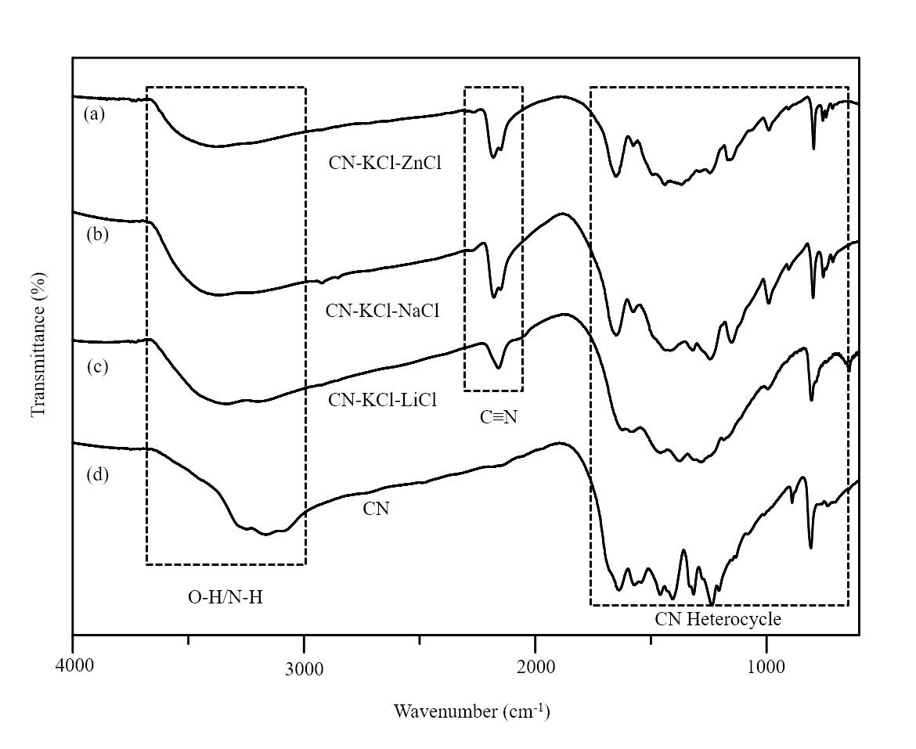

Figure 3: FTIR spectra of (a) CN, (b) CN-KCl-LiCl, (b) CN-KCl-NaCl, (c) CN-KCl-ZnCl2.

## Photocatalytic Activity

The photocatalytic performance of the prepared samples was evaluated in photocatalytic degradation of phenol under solar light irradiation for 6 hours and the activities are shown in Table 3. As shown in the Table 3, the reference CN showed only 10% of phenol degradation after 6 hours of solar irradiation while CN prepared in KCl-LiCl demonstrated 24% of phenol degradation which was almost 2.5 times higher than reference CN. On the other hand, there was no significant change in photocatalytic degradation of phenol when CN-KCl-NaCl and CN-KCl-ZnCl2 were used as both activities showed 14 and 7%, respectively. The improved photocatalytic degradation of sample CN-KCl-LiCl was mainly due to good mobility of charge carriers. It was stated that the directional flow of electrons depended on the organization of the molecules in the structure in relation to their crystallinity.

Therefore, it can be demonstrated that the efficient flow of electron transfer in the crystalline and well-ordered arrangement of the CN have a big influence to the photocatalytic performance [8]. In term of surface area, it was also suggested that surface area did not give an effect as the reference CN has a similar surface area in respect to CN-KCl-LiCl. Although the CN-KCl-NaCl showed amorphous phase as demonstrated by XRD pattern, the slightly better photocatalytic activity compared to reference CN might come from better adsorption in visible light as shown in DRUV-Vis analysis (Figure 2). For CN-KCl-ZnCl2, despite having a well-order arrangement as can be seen via XRD pattern, better adsorption in visible light range and surface area compared to CN-KCl-NaCl, the low photocatalytic activity (7%) might due to the decrease C-N groups as can be seen in DRUV-Vis analysis.

**Table 3** Photocatalytic Activity of the Prepared Samples

|  |  |
| --- | --- |
| **Samples** | **Activity (%)** |
| CN | 10 |
| CN-KCl-LiCl | 25 |
| CN-KCl-NaCl | 14 |
| CN-KCl-ZnCl2 | 7 |

**Conclusion**

The preparation of CN in various salt melts has been demonstrated. However, only CN prepared in KCl-LiCl showed a crystalline phase and improved structural order. KCl-LiCl plays an important role in improving the crystallinity of the material by acting as a reactive solvent during the synthesis of CN, and binds strongly to the condensation intermediates. Unlike KCl-NaCl and KCl-ZnCl2, the high melting point of both salt melts compared to temperature which condensation of CN took place, cause them unable to act as a solvent. The good crystallinity and better surface area possessed by CN-KCl-LiCl turned out to be highly active photocatalyst as it degraded phenol *ca.* 2.5 times than unmodified/reference CN. In summary, the preparation of CN in all salt melts improved the absorption in visible light range. FTIR and N2 adsorption-desorption isotherm suggest the presence of porous structure in all CN prepared in salt melts except for reference CN. Powder XRD analysis demonstrated only CN-KCl-LiCl shows crystalline phase while CN-KCl-ZnCl2 showed a well-order arrangement compared to others which showed amorphous phase. In order to increase the performance of crystalline CN in photocatalysis field, it is suggested that a better understanding and control of the condensation and crystallisation process is required in to synthesis a CN with high crystalline phase, improve absorption in visible light region and high surface area.

**Acknowledgement**

We thank Ministry of Higher Education and Universiti Teknologi Malaysia via Research University Grant (Cost Center Code: Q.J130000.2526.13H54). M.H.M.H would like to thank the financial support from MyBrain-MyPhD Scholarship.

**References**

[1] Cohen & Marvin L., *Calculation of bulk moduli of diamond and zinc-blende solids*. Physical Review B, **32**(12), 7988, 1985.

[2] Naffakh, M., López, V., Zamora, F., & Gómez, M. A., *Novel melt-processable nanocomposites based on isotactic polypropylene and carbon nitride: Morphology, crystallization, and dynamic mechanical properties*. Soft Materials, **8**(4), 407-425, 2010.

[3] Wang, X., Maeda, K., Thomas, A., Takanabe, K., Xin, G., Carlsson, J. M.,& Antonietti, M., *A metal-free polymeric photocatalyst for hydrogen production from water under visible light*, Nature materials, **8**(1), 76-80, 2009.

[4] Liu, J., Zhang, T., Wang, Z., Dawson, G., & Chen, W., *Simple pyrolysis of urea into graphitic carbon nitride with recyclable adsorption and photocatalytic activity*, Journal of Materials Chemistry, **21**(38), 14398-14401, 2011.

[5] Lee, S. C., Lintang, H. O., & Yuliati, L., *A urea precursor to synthesize carbon nitride with mesoporosity for enhanced activity in the photocatalytic removal of phenol*, Chemistry–An Asian Journal, **7**(9), 2139-2144, 2012.

[6] Goettmann, F., Fischer, A., Antonietti, M., & Thomas, A., *Chemical Synthesis of Mesoporous Carbon Nitrides Using Hard Templates and Their Use as a Metal‐Free Catalyst for Friedel–Crafts Reaction of Benzene*, Angewandte Chemie International Edition, **45**(27), 4467-4471, 2006.

[7] Shalom, M., Inal, S., Fettkenhauer, C., Neher, D., & Antonietti, M., *Improving carbon nitride photocatalysis by supramolecular preorganization of monomers*, Journal of the American Chemical Society, **135**(19), 7118-7121, 2013.

[8] Bhunia, M. K., Yamauchi, K., & Takanabe, K., *Harvesting solar light with crystalline carbon nitrides for efficient photocatalytic hydrogen evolution*, Angewandte Chemie International Edition, **53**(41), 11001-11005, 2014.

[9] Wirnhier, E., Döblinger, M., Gunzelmann, D., Senker, J., Lotsch, B. V., & Schnick, W., *Poly (triazine imide) with Intercalation of Lithium and Chloride Ions [(C3N3)2(NHxLi1−x)3⋅LiCl]: A Crystalline 2D Carbon Nitride Network*, Chemistry-A European Journal, **17**(11), 3213-3221, 2011.

[10] Chong, S. Y., Jones, J. T., Khimyak, Y. Z., Cooper, A. I., Thomas, A., Antonietti, M., & Bojdys, M. J., *Tuning of gallery heights in a crystalline 2D carbon nitride network*, Journal of Materials Chemistry A, **1**(4), 1102-1107, 2013.

[11] Sundermeyer, W., *Fused salts and their use as reaction media*, Angewandte Chemie International Edition, **4**(3), 222-238, 1965.

[12] Sundermeyer, W., *N‐Cyaniminosulfur Difluoride*, Angewandte Chemie International Edition, **6**(1), 90-91, 1967.

[13] Verbeek, W., & Sundermeyer, W., *Darstellung von Carbonyl‐und Fluorcarbonyl‐pseudohalogeniden in der Salzschmelze*, Angewandte Chemie, **79**(19), 860-861, 1967.

[14] Bojdys, M. J., Müller, J. O., Antonietti, M., & Thomas, A., *Ionothermal synthesis of crystalline, condensed, graphitic carbon nitride*, Chemistry-A European Journal, **14**(27), 8177-8182, 2008.

[15] Busca, G., Berardinelli, S., Resini, C., & Arrighi, L., *Technologies for the removal of phenol from fluid streams: a short review of recent developments*, Journal of Hazardous Materials, **160**(2), 265-288, 2008.

[16] Chun, H., Yizhong, W., & Hongxiao, T., *Destruction of phenol aqueous solution by photocatalysis or direct photolysis*, Chemosphere, **41**(8), 1205-1209, 2000.

[17] Ham, Y., Maeda, K., Cha, D., Takanabe, K., & Domen, K., *Synthesis and Photocatalytic Activity of Poly (triazine imide)*, Chemistry–An Asian Journal, **8**(1), 218-224, 2013.

[18] Boyarchuk, T. P., Khailova, E. G., & Cherginets, V. L., *Potentiometric measurements in molten chlorides. Solubilities of metal oxides in the molten eutectic mixture CsCl-KCl-NaCl at 600° C*, Electrochimica acta, **38**(10), 1481-1485, 1993.

[19] Fettkenhauer, C., Weber, J., Antonietti, M., & Dontsova, D., *Novel carbon nitride composites with improved visible light absorption synthesized in ZnCl 2-based salt melts*, RSC Advances, **4**(77), 40803-40811, 2014.

[20] Sam, M. S., Lintang, H. O., Sanagi, M. M., Lee, S. L., & Yuliati, L., *Mesoporous carbon nitride for adsorption and fluorescence sensor of N-nitrosopyrrolidine*, Spectrochimica Acta Part A: Molecular and Biomolecular Spectroscopy, 124, 357-364, 2014.

[21] Zhao, L., Chen, X., Wang, X., Zhang, Y., Wei, W., Sun, Y., & Titirici, M. M., *One‐Step solvothermal synthesis of a carbon@ TiO2 dyade structure effectively promoting visible‐Light photocatalysis*, Advanced Materials, **22**(30), 3317-3321, 2010.

[22] Matsunaga, T., Kim, J. K., Hardcastle, S., & Rohatgi, P. K., *Crystallinity and selected properties of fly ash particles*, Materials Science and Engineering: A, **325**(1), 333-343, 2002.

[23] Manecke, V. G., & Wöhrle, D., *Synthese und halbleitereigenschaften einiger komplexe und der aus ihnen hergestellten polymeren. Teil 2. Polymere mit phthalocyaninartiger und triazinartiger stuktur*, Macromolecular Chemistry and Physics, **120**(1), 176-191, 1968.